**Overview**

*Duration is 1 min*

In this lab you will demonstrates how to implement different image models on MNIST using the tf.keras API and define a DNN on MNIST to do image classification.

**Learning Objectives**

In this lab, you will:

* Understand how to build a Dense Neural Network (DNN) for image classification
* Know how to deploy and use an image classifcation model using Google Cloud's AI Platform

**Setup**

For each lab, you get a new Google Cloud project and set of resources for a fixed time at no cost.

1. Make sure you signed into Qwiklabs using an **incognito window**.
2. Note the lab's access time (for example,  and make sure you can finish in that time block.

There is no pause feature. You can restart if needed, but you have to start at the beginning.

1. When ready, click .
2. Note your lab credentials. You will use them to sign in to the Google Cloud Console. 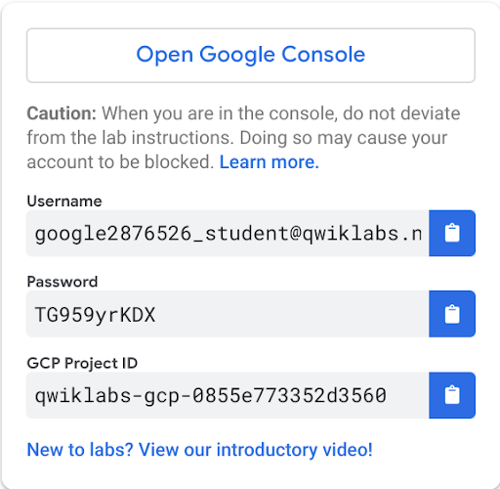
3. Click **Open Google Console**.
4. Click **Use another account** and copy/paste credentials for **this** lab into the prompts.

If you use other credentials, you'll get errors or **incur charges**.

1. Accept the terms and skip the recovery resource page.

Do not click **End Lab** unless you are finished with the lab or want to restart it. This clears your work and removes the project.

**Create Storage Bucket**

Create a bucket using the GCP console:

**Step 1**

In your GCP Console, click on the **Navigation menu** (), and select **Storage**.

**Step 2**

Click on **Create bucket**.

**Step 3**

Choose a Regional bucket and set a unique name (use your project ID because it is unique). Then, click **Create**.

**Launch AI Platform Notebooks**

To launch AI Platform Notebooks:

**Step 1**

Click on the **Navigation Menu**. Navigate to **AI Platform**, then to **Notebooks**.

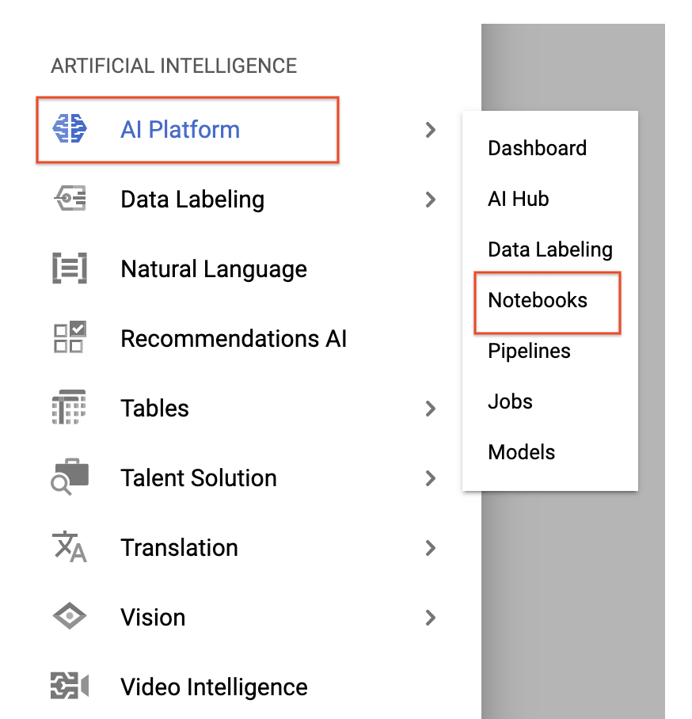

**Step 2**

On the Notebook instances page, click NEW INSTANCE. Select the latest version of TensorFlow 2.x *without GPUs*.

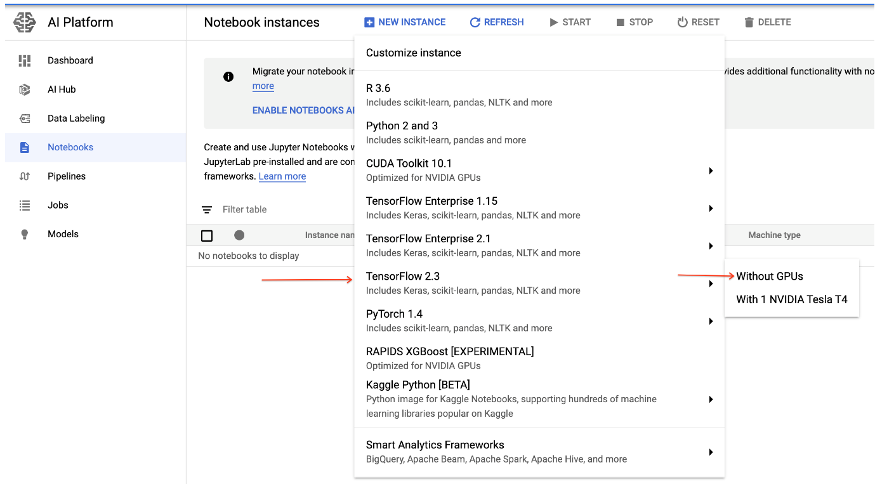

In the pop-up, confirm the name of the deep learning VM, move to the bottom of the window and click **Create**.

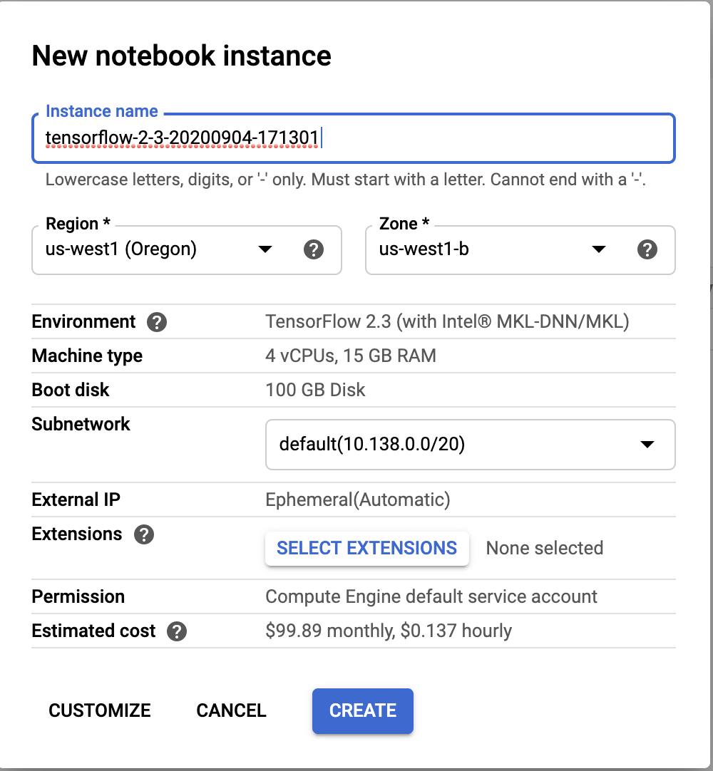

The new VM will take 2-3 minutes to start.

**Step 3**

Click **Open JupyterLab**. A JupyterLab window will open in a new tab.

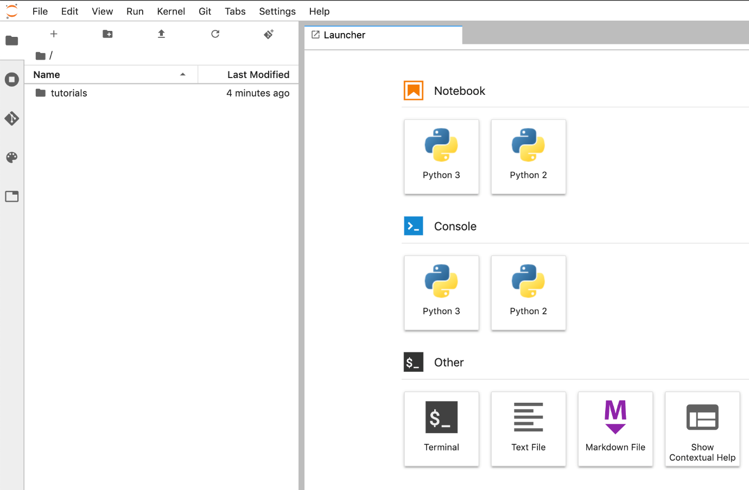

**Clone course repo within your AI Platform Notebooks instance**

To clone the training-data-analyst notebook in your JupyterLab instance:

**Step 1**

In JupyterLab, click the **Terminal** icon to open a new terminal.

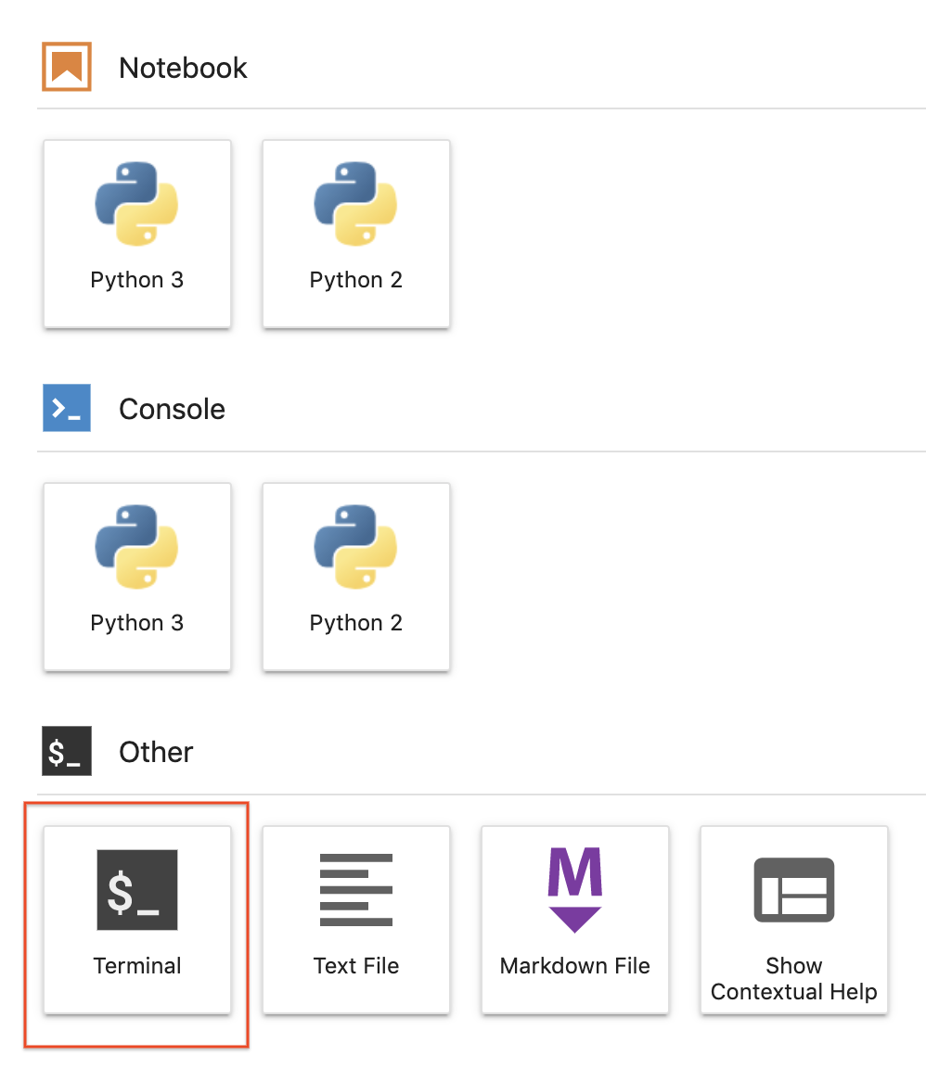

**Step 2**

At the command-line prompt, type in the following command and press **Enter**.

git clone https://github.com/GoogleCloudPlatform/training-data-analystcontent_copy

**Step 3**

Confirm that you have cloned the repository by double clicking on the training-data-analyst directory and ensuring that you can see its contents. The files for all the Jupyter notebook-based labs throughout this course are available in this directory.

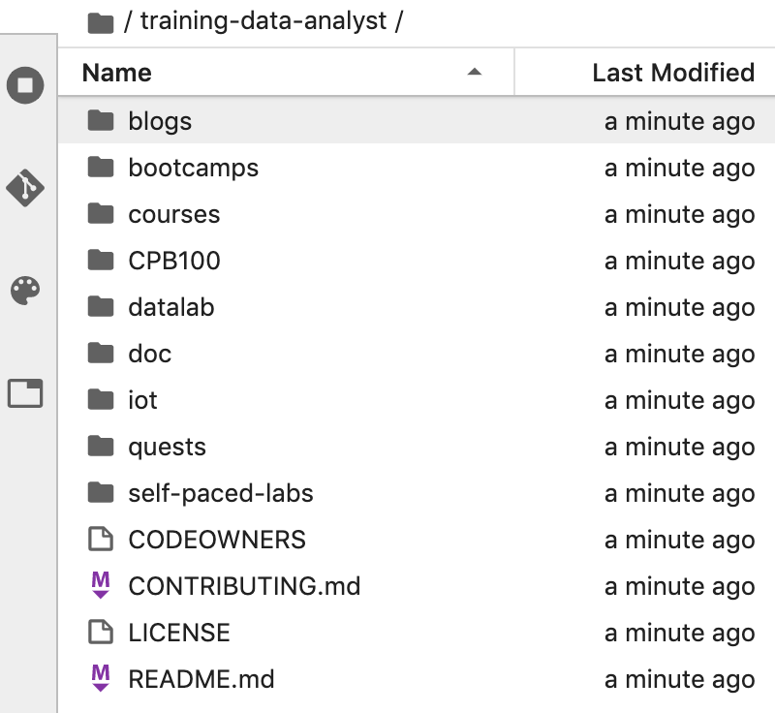

**Image Classification with a Deep Neural Network Model**

*Duration is 60 min*

**Step 1**

In the notebook interface, navigate to **training-data-analyst > courses > machine_learning > deepdive2 > image_classification > labs > 2_mnist_models.ipynb**.

**Step 2**

In the notebook interface, click on **Edit > Clear All Outputs** (click on Edit, then in the drop-down menu, select Clear All Outputs).

Carefully read through the notebook instructions and fill in lines marked with #TODO where you need to complete the code as needed

Tip: To run the current cell you can click the cell and hit **shift** **enter**. Other cell commands are found in the notebook UI under **Run**.

In the first cell, make sure to replace the project id, bucket and region with your qwiklabs project id, your bucket, and bucket region respectively. Also, change the MODEL_TYPE to *dnn*.

* Hints may also be provided for the tasks to guide you along. Highlight the text to read the hints (they are in white text).
* If you need more help, you may take a look at the complete solution by navigating to **training-data-analyst > courses > machine_learning > deepdive2 > image_classification > solutions** and opening **2_mnist_models.ipynb**.

**End your lab**

When you have completed your lab, click **End Lab**. Qwiklabs removes the resources you’ve used and cleans the account for you.

You will be given an opportunity to rate the lab experience. Select the applicable number of stars, type a comment, and then click **Submit**.

The number of stars indicates the following:

* 1 star = Very dissatisfied
* 2 stars = Dissatisfied
* 3 stars = Neutral
* 4 stars = Satisfied
* 5 stars = Very satisfied

You can close the dialog box if you don't want to provide feedback.

For feedback, suggestions, or corrections, please use the **Support** tab.

©2020 Google LLC All rights reserved. Google and the Google logo are trademarks of Google LLC. All other company and product names may be trademarks of the respective companies with which they are associated.